Architecture Week returns with a ‘from home’ edition

The fourth edition of this event starts on Thursday 17 May and offers over a hundred activities adapted into a virtual format, inviting people to open a new window and delve into the world of architecture from home, through the internet, social media, television and radio

Houses and the domestic domain take centre stage in a programme with talks and resources which use architecture to talk about space, living alongside others and everyday well-being

The city’s coastline will be the guest space, with a virtual bike ride along the coast, web exhibitions, a roundtable and other activities reflecting on the opportunities for change represented by the waterfront and the port areas

The virtual architecture festivals in the city’s ten districts offer a chance to rediscover urban space and places of interest in the neighbourhoods, with drawing competitions, live events and presentations such as the announcement of short-listed projects and winners of the FAD architecture and urban planning awards

Architecture Week returns with a virtual edition to enjoy from home. The fourth edition of this annual shared event starts on Thursday 17 May, once again offering a broad array of activities relating to the realm of architecture and the architectural heritage of Catalonia’s capital.

The 2020 edition invites people to open a new window and delve into the world of architecture without leaving their domestic environment, through the internet, social media, television and radio. The remote programme features over a hundred activities, including streamed talks and meetings, debates, virtual tours of various spaces in the city and other content created from the new frontiers being generated by the current situation.

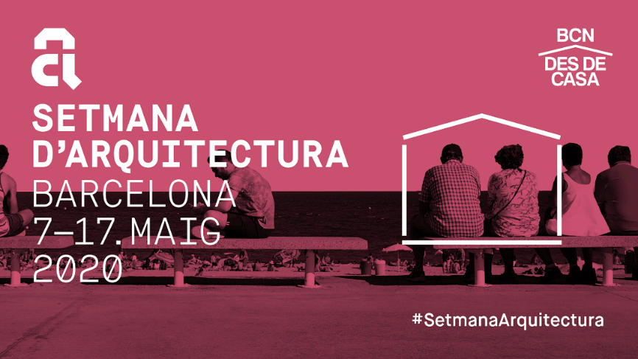

Using this new format, the event will become a meeting point for a wide range of activities relating to the world of architecture and the city, beyond disciplinary and territorial boundaries. All this, with the desire to prompt reflection on the built environment of cities and its value through the dissemination of architectural activity, knowledge, experience and debate.

This year's edition is using the city’s coastal area as its guest space, inviting us to take part in a collective reflection on the city by the sea, the great coastal and port spaces and the opportunities for change and conflict that take shape there.

In addition, there's another unexpected protagonist, given little visibility to date: the domestic domain, very present and visible in our own daily lives but also in the public realm in recent weeks.

One of the highlights in this area will be a discussion entitled ‘The Value of Architecture. The Value of the City’, which will be looking at the importance acquired by concepts such as public space, architecture, the urban model and the quality of housing in the current situation with the state of alert and lockdown. The session is on Tuesday 12, at 6 pm, and the participants are the Second Deputy Mayor, Janet Sanz, the dean of the Architects’ Association of Catalonia (COAC), Assumpció Puig, and the architects Juli Capella and Olga Subirós. The session will be streamed at <https://www.youtube.com/wwwbcncat>.

Architecture Week is promoted by Barcelona City Council, the COAC and the Mies van der Rohe Foundation, in collaboration with Barcelona Building Construmat and ArquiniFAD. The aim of the event is to increase the value of the built urban environment for the general public through the dissemination of architecture and knowledge.

Architecture Week once again has its own complete website detailing the full programme and providing information on each activity:

<https://www.barcelona.cat/setmanadarquitectura/>

**Home-made special**

Present circumstances force us to give up iconic sites in Barcelona’s districts or the headquarters of Architecture Week’s organisers as this year's star attractions, and to settle for our homes instead. The current hyper-visibility of contemporary small domestic spaces has turned into a magnificent opportunity for talking about space, social cohesion and everyday well-being from an architectural perspective.

The current situation is producing more and more new formats and offering us initiatives that allow us to learn about everything going on at the moment through architecture. This is a selection of initiatives and projects that have come about through our new home-based reality:

* ‘With C for Confinement’ is a cycle of talks organised by a group of architecture students as an event calling for de-institutionalised culture.
* ‘A thousand homes in your home’ is an initiative from the Barcelona School of Architecture (ETSAB) Thematic Workshop Arquitectxs de Capçalera that has mapped out the intensive uses of students’ and teachers’ domestic spaces.
* ‘Lluèrnia at home’ offers an ad hoc version of this fire and light festival held in Olot, which has invited creators this year to make their proposals from home and compiled them on video and photographs. You can still send your proposals to #LluerniaAtHome.
* Draw your home, organised by Urban Sketchers Barcelona.
* ‘A confined place’, debate organised by ETSA, the La Salle School of Architecture.
* Archisolation, images of quarantine. Exhibition by Federico Babina.
* Collection of lockdown initiatives by young architects, presented by AJAC, the Catalan Young Architects Group.

**Guest space: the Barcelona coastline**

The coastal region is the guest space at this edition of Architecture Week. The great coastal and port spaces represent opportunities for change and conflict in contemporary European cities, and Barcelona is no exception. Architecture Week will be encouraging collective reflection on the coastal region and the city by the sea, through exhibitions and virtual tours, live debates and other initiatives such as the ones listed below.

* ‘Architectures on the Waterfront’. During Architecture Week, you can take virtual tours of the exhibition held at the Barcelona Maritime Museum in November, the result of collaboration between Architects for Architecture and the Mies van der Rohe Foundation. The exhibition features a selection of works nominated for the EU Prize for Contemporary Architecture – Mies van der Rohe Award located on the waterfront that establish a new connection with the city.
* Opening talk and roundtable on the exhibition ‘Architectures on the Waterfront’, with the exhibition curator Francesc Muñoz, PhD in Urban Geography from the UAB, Elías Torres, co-architect of the solar pergola at El Fòrum, and Francis Rambert, director of La Cité d’architecture in Paris, moderated by Anna Sala.
* ‘Virtual bike tour along Barcelona’s coast’, a proposal from the COAC to cover Barcelona’s entire coastline, from the Llobregat lighthouse to El Besòs beach.
* ‘Waterfront Ideas’, a series of quick presentations in PechaKucha format around the present and future of Barcelona's coastal region and the result of collaboration between Barcelona Regional, Architects for Architecture and the Mies van der Rohe Foundation.
* Online roundtable: ‘Architecture chat shows: climate change, architecture and engineering the reconstruction of the Port del Fòrum’, by ASAC.
* ‘Living on the beach’, a presentation of the 32nd Habitàcola Awards, promoted by ARQUIN-FAD and aimed at design and architecture students to encourage critical reflection on contemporary challenges.
* ‘EINA a Habitàcola’, virtual presentation specifically on the eight EINA school projects for the Habitàcola Awards.
* Activities for children to discover the heritage by water, organised by the Barcelona City Council Directorate for Urban Architecture and Heritage, in collaboration with Parks and Gardens.
* Presentation of the map-guide Barceloneta: history, architecture and public art.
* Architecture in short. Short films on architecture along the shore.

**Architecture festivals**

Initially planned as ten public meetings around ten iconic spaces in each of Barcelona’s districts, the Architecture Festivals now use a new format to invite us to discover amazing and little-known corners of our neighbourhoods without leaving home. Architecture Week thus reaches out to all the city’s districts, offering a chance to rediscover neighbourhood architecture.

This year's Architecture Festivals were created through the Territorial Groups of the Barcelona Branch of the Architects’ Association of Catalonia (COAC), supported by social networks and sponsored by organisations and universities.

**Architecture & The Media**

Architecture Week also offers live streaming sessions of the second edition of the European Conference on Architecture & the Media, organised by the Mies van der Rohe Foundation under the framework of the EU Prize for Contemporary Architecture – Mies van der Rohe Award.

Five sessions with talks, roundtables and workshops focused on the dissemination of architecture through the radio and television, and their digital versions, which the eminent photographer Iwan Baan will conclude.

**Architecture in the classroom**

This ‘from home’ edition of Architecture Week gives children and young people access to some thirty activities chosen from the ‘Architecture in the classroom’ programme, which could not be held in schools this year as planned.

The aim behind this project from the Architects’ Association is to bring architecture to primary and secondary schools and give young children and teenagers a new approach to the spaces that accompany them, excite them, build relationships, create inclusive dynamics and that are an expression of the civilisation and culture of our times.

**ArquinFilm and FAD Awards for Architecture and Interior Design**

This year sees our film and architecture exhibition, ArquinFilm, organised by ARQUIN-FAD as part of Architecture Week, switch from the Filmoteca’s big screen, where the cycle is usually held, to our home screens. In collaboration with Betevé (Barcelona TV), the cycle will be broadcast from 7 to 17 May, open to everyone and for all audiences.

The awards ceremony for the finalists and winners of the FAD Awards for Architecture and Interior Design, organised by ARQUIN-FAD, will also be broadcast live on 7 May.

**Reading room**

We are opening a new reading space for Architecture Week thanks to the city’s main architecture bookshops and specialist publishers, who are offering summaries of publications accessible to everyone and, through the Architecture Bookshops initiative, are organising discounts and prize draws for packs of books during the week.

**For little ones**

Architecture Week offers a series of ‘from home’ activities for kids. A drawing competition for children, workshops on building a geodesic dome using household materials, a Canadian cabin with bars or straws, a structure in the shape of a snail’s shell or a hyperboloid of revolution, along with 30 activities and workshops from the ‘Architecture in the classroom’ programme and ten workshops linked to the Architecture Festivals in the districts are just some of the activities to learn with children from home.